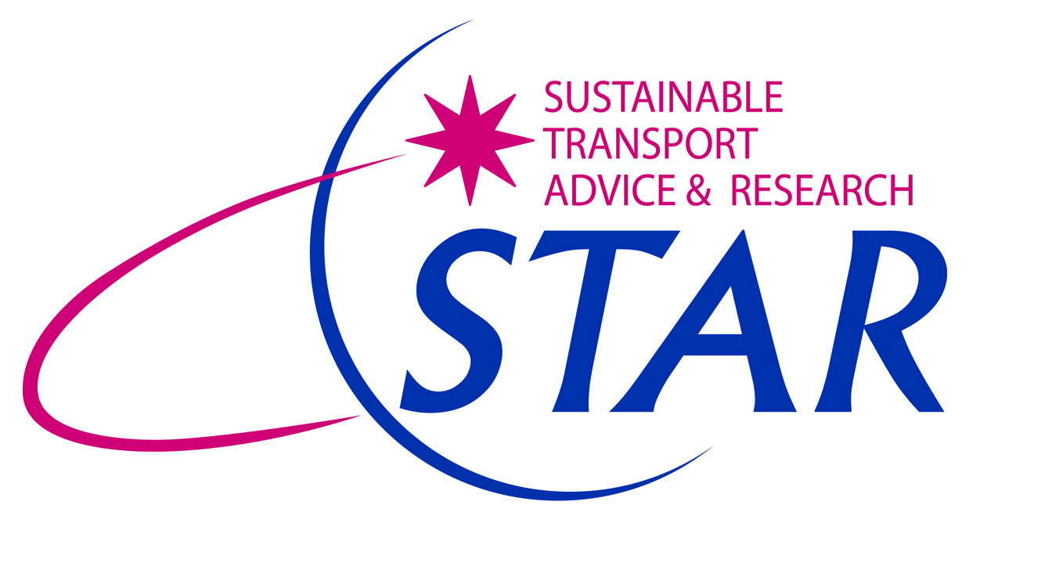
Community Transport for the 21st Century

STAR has been hard at work on a range of projects designed to bring traditional community transport right up to date. As a transport provider, the Voluntary and Community Sector is coming of age – why not let STAR help you to get the most out of your local operators?

We are experts in developing community transport solutions and assisting community transport operators to become more socially enterprising. For example:

- We recently completed two studies for Nottinghamshire County Council, in partnership with the local community transport operators, to assess the demand for and feasibility of new community minibuses for Broxtowe Borough and Bassetlaw District. We consulted widely with professional stakeholders and potential end users to inform recommendations and business plans for each area
- On behalf of Derbyshire County Council, we conducted an independent review of the Council-funded Dial-a-Bus services. In consultation with the operators, we reviewed current scheduling and operational practices and made recommendations for more efficient operation in the short term. For the long-term, we developed a roadmap to achieve the desired future direction for Dial-a-Bus in the County.
- We worked with Rutland County Council to assess the feasibility and commercial viability of a new social enterprise to deliver minibus services for Rutland. We investigated likely markets for a new social enterprise, identified potential funding sources and prepared a costed business plan for establishing the organisation.

We also have considerable expertise in preparing successful transport funding bids. We can assist with bids for LSTF funding, Lottery awards and drawing down funds from the EU. We are willing to enter into partnership with local authorities and operators to secure shared funding for community transport operations.

We are full of ideas. Contact STAR today to discuss how we can work together to bring community transport into the 21st century in your area.

Clare Waldron and Norman James
Directors
STAR Independent Consultants Limited
M: 07867 871405 or 07917 692443
clare@startransport.co.uk
norman@startransport.co.uk
www.startransport.co.uk

